Sprint 1 - Endurance Design Document

March 27, 2022

Use this Requirements Specification template to document the requirements for your product or service, including priority and approval (Must do).
This document will also serve as a System Design Document (How to) and will include sections detailing system flow, algorithms, staffing plan, software/hardware, and Test Plan
This document contains instructions and examples which are for the benefit of the person writing the document and should be removed before the document is finalized.
To regenerate the TOC, select all (CTL-A) and press F9.
Table of Contents
1. Executive Summary 3
1.1 Project Overview 3
1.2 Purpose and Scope of this Specification 3
2. Product/Service Description 3
2.1 Product Context 3
2.2 User Characteristics 3
2.3 Assumptions 3
2.4 Constraints 3
2.5 Dependencies 4
3. Requirements 4
3.1 Functional Requirements 5
3.2 Security 5
3.2.1 Protection 5
3.2.2 Authorization and Authentication 6
3.3 Portability 6
4. Requirements Confirmation/Stakeholder sign-off 6
5. System Design 6
5.1 Algorithm 6
5.2 System Flow 6
5.3 Software 6
5.4 Hardware 6
5.5 Test Plan 7
5.6 Task List/Gantt Chart 7
5.7 Staffing Plan 7

Executive Summary

Project Overview
This project is to test our knowledge of software engineering. We test our knowledge of making algorithms, testing code, and making flow charts. Each group is assigned a robot that must do the following: Go around the endurance course. There are a series of requirements the robot must do while doing this course. Like color changes, speaking, and staying on the path.

Purpose and Scope of this Specification
In scope
Modification of the first sprint, give a good deep analysis of sprint 1. It helps us gain experience.

Out of Scope
It helps give us knowledge for sprint 2. Gets us ready for any changes that need to be made for upcoming projects and assignments.

Product/Service Description
Some General factors that can affect the product and its requirements are:
- Robot battery
- Room availability
- Group member availability
- Other groups working on at the same time

Product Context
It relates to other products because we are basically in our own software engineering group, working on a project. It relates to real world scenarios for future software engineers because you work in a group, and each member must do their part.

User Characteristics
Create general customer profiles for each type of user who will be using the product. Profiles should include:
- Professors
- Students
- Group members
- Kids
- No experience required
- People do not need any technical expertise

Assumptions
We would assume:
- that the rooms would be available on the times listed
- Our group will meet when scheduled too
- The robot block code will work when started
- The Robot is fully functioning and charged

Constraints
- The room is not available
- The robot isn’t charged
- The block code doesn’t work
- Only one member of the group can meet
- The course tape is ripped

Dependencies
- Robot must be charged
- Door to room must be unlocked
- Building must be open
- Sphero Edu app must be available with the code
- Lights in the room must work
- Area must be clear
Requirements
- In the following table there are a list of requirements that must be met to successfully complete the project. The robot must start in the yellow corner, with a green light. The robot must speak when the program starts. The robot must make it to each corner while maintaining the path of the line. When the robot reaches the last corner, it must speak and the color must go red.
Priority Definitions
The following definitions are intended as a guideline to prioritize requirements.
- Priority 1 – States the requirements that must be met to achieve the goal
- Priority 2 – States certain secondary needs that can help make the robots path of travel and code more accurate.
- A good requirement is:

Functional Requirements

Req# | Requirement | Comments | Priority | Date Reviewed | SME Reviewed/Approved
Endur_01 | Blue light faces opposite direction of initial | Not required, however, to go on the right path alignment is vital | 2 | 3/24/2022 | Approved
Endur_02 | Robot Starts in first corner of Yellow Square, with a green light |  | 1 | 3/4/2022 | Approved
Endur_03 | Robot speaks, “Ready, Set, Go!” |  | 1 | 3/4/2022 | Approved
Endur_04 | Robot goes straight to second corner |  | 1 | 3/4/2022 | Approved
Endur_05 | Robot Stops at Second corner | Helps make the robot stay on the right path of travel, more accurately | 2 | 3/4/2022 | Approved
Endur_06 | Robot turns right |  | 1 | 3/4/2022 | Approved
Endur_07 | Robot goes straight to the third corner |  | 1 | 3/4/2022 | Approved
Endur_08 | Robot Stops at third corner | Helps make robot stay on the right path, more accurately | 2 | 3/4/2022 | Approved
Endur_09 | Robot turns right |  | 1 | 3/4/2022 | Approved
Endur_10 | Robot goes straight to fourth corner |  | 1 | 3/4/2022 | Approved
Endur_11 | Robot Stops at fourth corner | Helps make robot stay on the right path, more accurately | 2 | 3/4/2022 | Approved
Endur_12 | Robot turns right |  | 1 | 3/4/2022 | Approved
Endur_13 | Robot goes straight to final corner/starting position |  | 1 | 3/4/2022 | Approved
Endur_14 | Robot stops and light turns red |  | 1 | 3/4/2022 | Approved
Endur_15 | Robot Speaks “I am done and need water!” and program ends |  | 1 | 3/4/2022 | Approved

Security

Protection
- We all have our own emails and passwords that aren’t shared
- Our laptops and devices are locked with passcodes so no one can get in
- The Sphero Edu app is linked up to our personal emails where only we can view our code
- Our Git Hub is private so no one can see

Authorization and Authentication
- Only we can work on our code and test the robot
- The Professor has access to the robot’s code
- Git Hub has authorization and requires you to sign in

Portability
- Our laptops are portable
- Our Sphero Robot is portable
- The Sphero Edu app is on every device, so we always have access to it

Requirements Confirmation/Stakeholder sign-off
Meeting Date | Attendees Name and Role | Comments
3/17/2022 | Brandon, Xabien  (Block code program) | Failed Meeting. The robot did not connect, and we were unable to test the code.
3/24/2022 | Brandon, Joshua, Xabien  (Block code program) | Successful meeting. After many failed attempts of getting the robot to stay on path and find out the times for the distance, we finally had a successful run of the endurance sprint.

System Design

Algorithm:
- Set Speed to 35
- Start Program
- Set Main light to green
- Speak: Ready, Set, Go!
- Go Straight for 18.5 seconds
- Stop
- Turn 90 degrees and roll for 10.5 seconds
- Stop
- Turn 180 degrees and roll for 18.5 seconds
- Stop
- Turn 270 degrees and roll for 10 seconds
- Stop
- Set Main light to Red
- Speak: I am done and need water!
- End Program

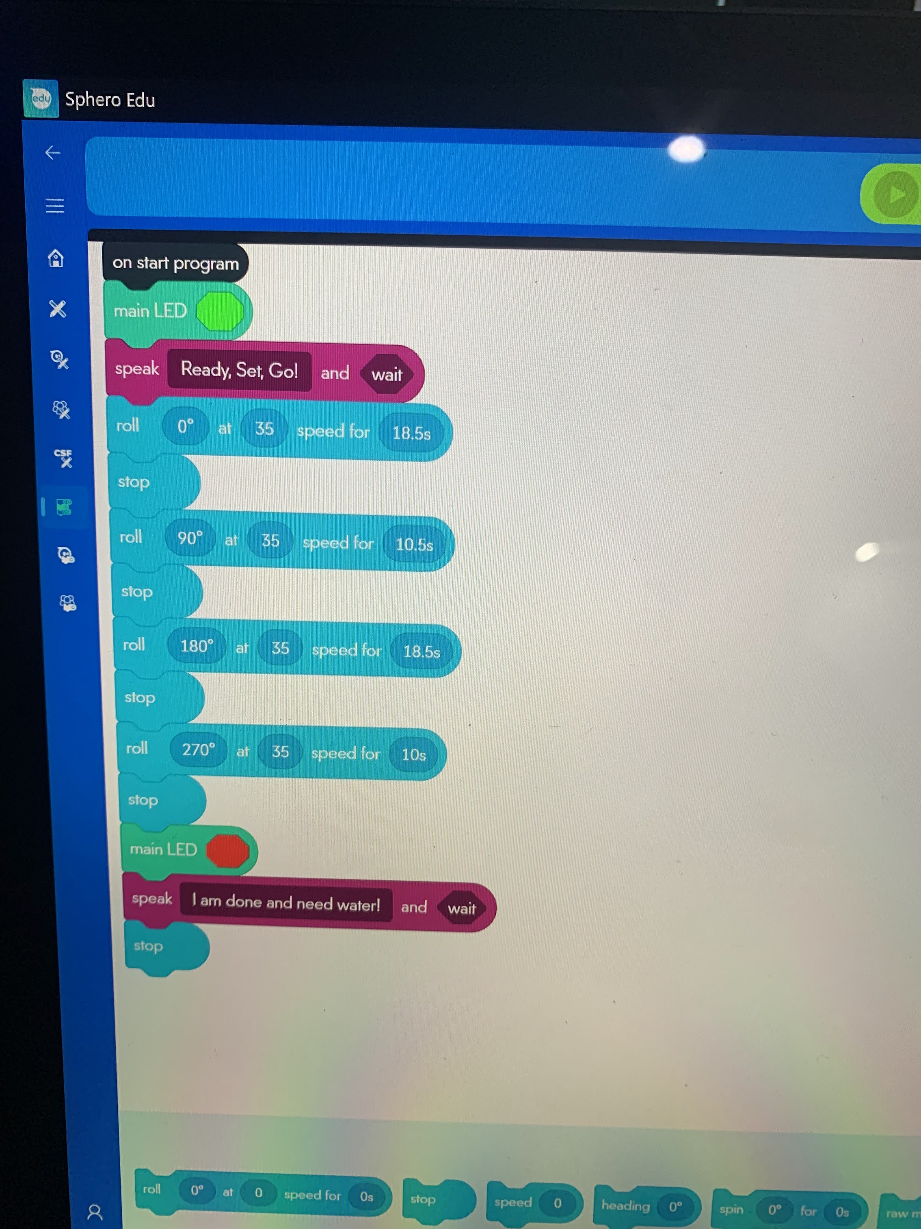

System Flow
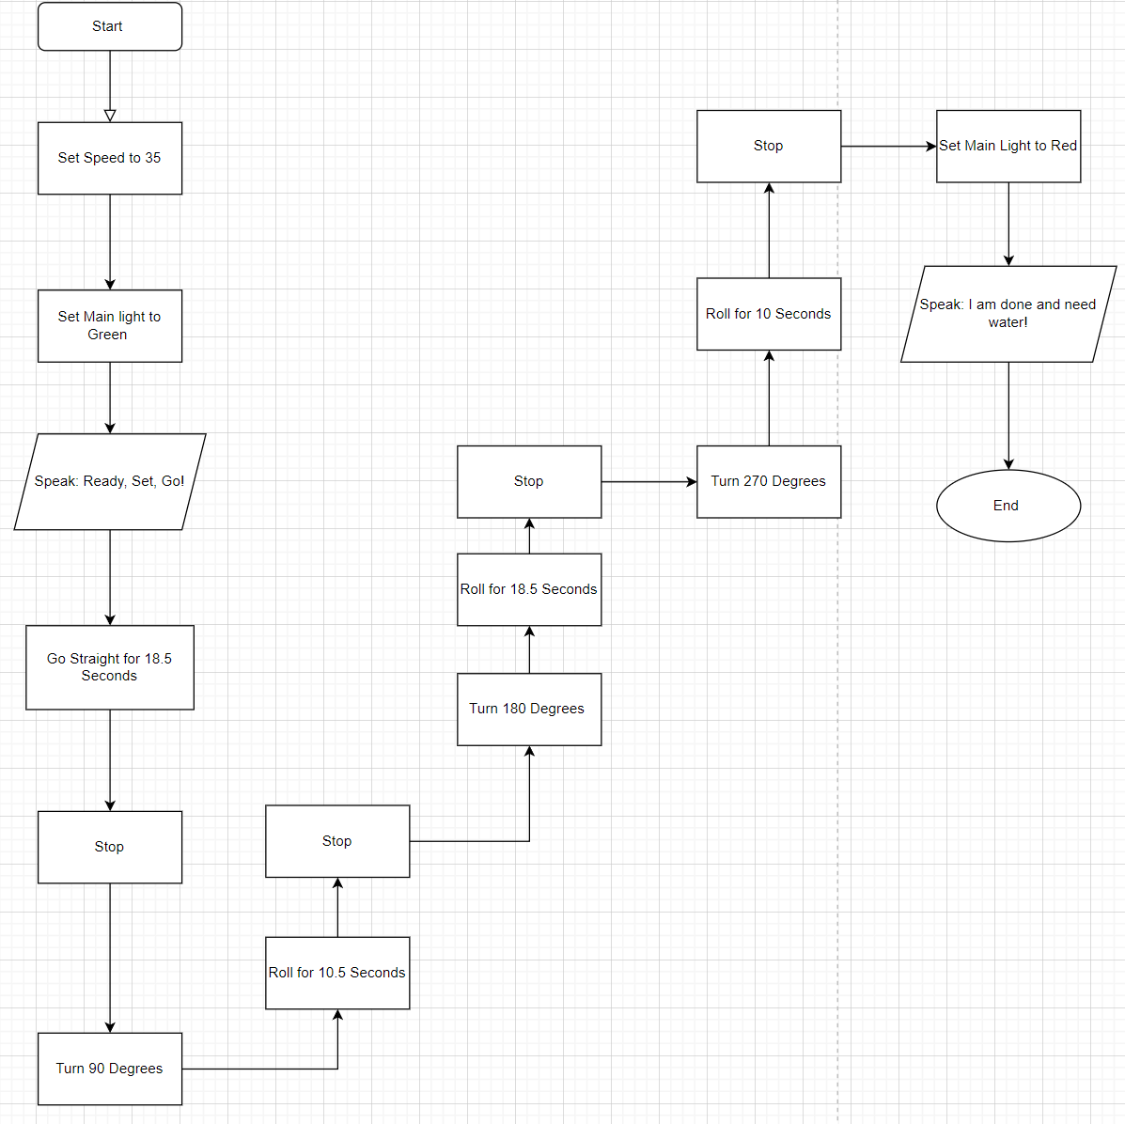

Software
The software language used in this program was block code from Sphero Edu

Hardware
The Hardware platforms that were used to design and test this, was Sphero Edu app as well as Draw.io

Test Plan

Reason for Test Case | Test Date | Expected Output | Observed Output | Staff Name | Pass/Fail
Testing Block Code | 3/23/22 | Making a rectangle | Moved in a rectangle but did not follow path perfectly | Xabien | Pass
First straight attempt | 3/23/22 | Make a straight line and stop at the end of the first route | Went too far | Brandon | Fail
Second straight attempt | 3/23/22 | Make a straight line and stop at the end of the first route | Too short, went off course | Brandon | Fail
Third Straight attempt | 3/23/22 | Make a straight line and stop at the end of the first route | Met expected result | Brandon | Pass
First attempt at half rectangle | 3/23/22 | Make a straight line and stop to turn, continue to next stop | Met expected result | Brandon | Pass
First attempt at full run | 3/23/22 | Run full course and keep within 5 inches of tape | Failed, too far on second leg and too far off tape | Brandon | Fail
Second attempt at full run | 3/23/22 | Run full course and keep within 5 inches of tape | Failed, continued too far off end point | Brandon | Fail
Third attempt at full run | 3/23/22 | Run full course and keep within 5 inches of tape | Met expected result | Brandon | Pass

Task List/Gantt Chart
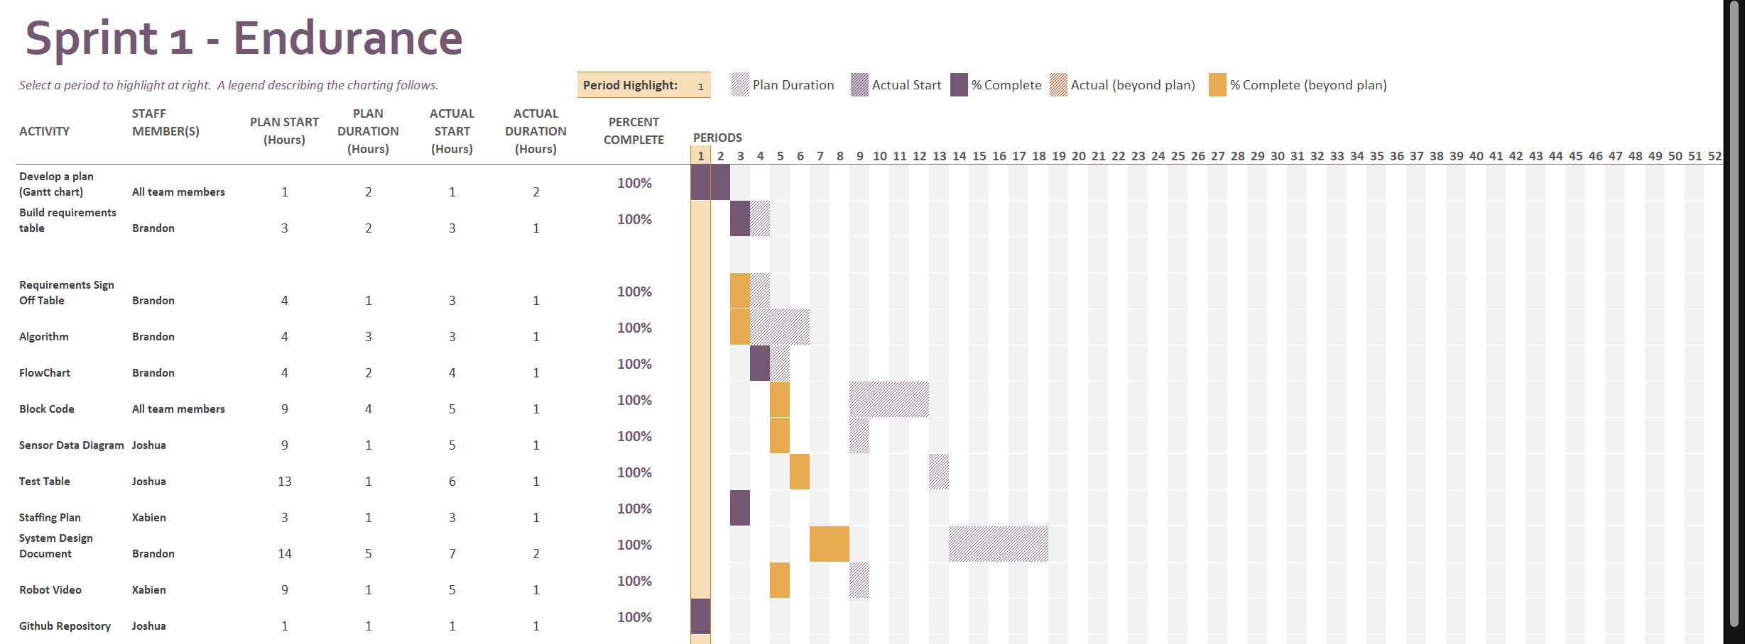

Staffing Plan
Name | Role | Responsibility
Develop a plan (Gantt chart) | Planning | All team members
Build Requirements table | Planning | Brandon
Requirements Sign Off Table | Planning | Brandon
Algorithm | Provide the required performance of our software | Brandon
Flowchart | accurately depicts how our software application will act to fulfill the algorithm | Brandon
Block code | Instructs the robot to complete the course | All team members
Sensor Data Diagram | Data | Originally Joshua but later was Xabien
Test Table | Data | Joshua
Staffing Plan | a chart/table that depicts the roles and responsibilities of each member | Xabien
System Design Document | detailing system flow, algorithms, staffing plan, software/hardware, and Test Plan | Brandon
Robot video | Video showing robot fulfilling the correct instructions | Xabien
GitHub Repository | All members submit their work here | Joshua

